Media release under embargo until: 10:00am (GMT) on Thursday 30 April 2020
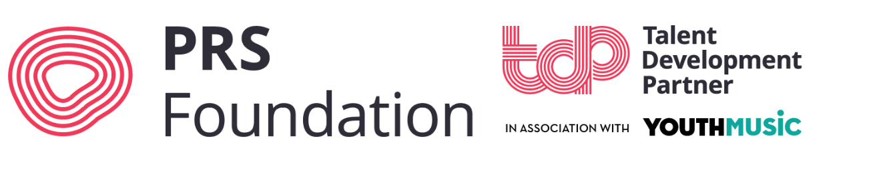
49 UK music organisations announced as PRS Foundation Talent Development Partners

- 12 of the organisations to receive additional funding as part of the Youth Music partnership

PRS Foundation, the UK’s leading charitable funder of new music and talent development, announces today (Thursday 30 April 2020) the 49 organisations around the country supported to be PRS Foundation Talent Development Partners for 2020/21:
- Audio Active
- Baby People
- Brighter Sound
- Bristol Music Trust
- British Underground
- Britten Sinfonia
- Café OTO
- Cheltenham Festivals
- Cryptic
- Drake Music
- Drake Music Scotland
- English Folk Dance and Song Society
- FOCUS Wales
- Forté Project
- Future Bubblers
- Generator
- Hard Rain SoloistEnsemble
- Heart n Soul
- Huddersfield Contemporary Music Festival
- Jazzlines
- Jazz re:freshed
- LIMF Academy
- Manchester Jazz Festival
- Mercury Musical Developments & Music Theatre Network
- Moving on Music
- Norwich Arts Centre
- Oh Yeah Music Centre
- Opera North
- Oxford Contemporary Music Festival
- Psappha
- PUNCH
- Red Note Ensemble
- Saffron Records
- Sage Gateshead
- Scottish Music Centre
- Serious
- Snape Maltings
- Sneaky Petes
- Sound and Music
- Sound Festival
- The Music Works
- The Roundhouse Trust
- The Tin Music and Arts
- The Warren Youth Project
- Tomorrow's Warriors
- Tŷ Cerdd
- Urban Development
- Wide Days
- Yorkshire Music Forum

Launched in 2016 and expanding each year, this pioneering network of Talent Development Partners brings together organisations working at the frontline of talent development in the UK, supporting a broad range of music creators across different music genres, career levels and UK regions.

The network – which includes venues, festivals, rehearsal spaces, studios and other talent development experts - reaches over 5,000 diverse and exciting songwriters, composers, artists, bands, ensembles and producers each year.

Organisations are selected because of the quality and range of opportunities on offer for music creators in their specialist field or region, the year-round impact of their work, and because of what they bring to the network.

New to join the network are organisations Audio Active (South East), Baby People (Midlands), Moving on Music (Northern Ireland), Oxford Contemporary Music (South East), and Wide Days (Scotland).

Talent Development Partners receive a grant from the Foundation for their year-round activity. They also work closely together and with PRS Foundation to address talent pipeline gaps through joint work and signposting. Hundreds of creators are already benefitting from the strategic partnership opportunities which have resulted from working together.

Funded activities include composer and songwriter development workshops, residencies, recording and release support, commissioning new music, live programming, advice and mentoring. Creators supported by Talent Development Partners include Little Simz, Lewis Capaldi, Ben Lunn, Yazz Ahmed, Charlotte Bray, Moses Boyd, Sam Fender and Yola.

In March 2020 PRS Foundation announced a new partnership with Youth Music, with support from players of People’s Postcode Lottery, for the Talent Development Partner network. Additional funding and the support of Youth Music’s team will bring career development opportunities to young people across England, Scotland and Wales, helping to break down the barriers to the music industries which many young creatives face. This year, 12 organisations will be receiving this additional support – Café OTO, Drake Music Scotland, FOCUS Wales, Forté Project, Manchester Jazz Festival, Norwich Arts Centre, Psaphha, Tŷ Cerdd, Jazzlines, The Tin Music and Arts, LIMF Academy and Wide Days.

As with other grantees, PRS Foundation has been supporting Talent Development Partners through the unprecedented challenges facing organisations and music creators due to the COVID-19 pandemic. Network member festivals, venues and programming bodies face particularly tough months ahead. The determination of the network to ensure that it meets the changing needs of music creators has been admirable, with many adapting programme focus and delivery for the lockdown period and making plans for post-lockdown delivery.

Notable support on offer during this period includes the launch of The Warren’s Amped digital platform, Drake Music’s advocacy of digital accessibility, Sound and Music’s Hardship Funding advice and new COVID-19 Composer Awards, Baby People’s online Hip Hop tutorial videos, Red Note Ensemble’s live stream performances, and many Partner-run online workshops and networking events.

Joe Frankland, CEO of PRS Foundation said “I would like to welcome the 49 organisations to this year’s Talent Development Partner network. Since the launch of this network in 2016 we have been increasingly inspired with the energy and impact that the brilliant people in each organisation have brought to this network and how important they are to the talent development pipeline for music creators across the UK and the wider music industry infrastructure. Despite facing significant COVID-19 related challenges this year, the network has been proactive in responding to the changing needs of creators and we look forward to working closely with all 49 organisations over the next 12 months.”

Matt Griffiths, CEO of Youth Music said “Young people just starting out in the music industries are being hit particularly hard by the COVID-19 pandemic – in addition to the barriers those from low income backgrounds were already facing. We’re really pleased to partner with PRS Foundation to support the next generation of musicians. Thanks to funding from players of People’s Postcode Lottery, we’re able to extend our support to projects in Wales and Scotland, as well as continuing to invest in English organisations.”

Ends.

For further information please contact:
Liam McMahon, Senior Communications Manager, PRS Foundation
07834625985 / liam@prsfoundation.com

Notes to Editors

About PRS Foundation
PRS Foundation is the UK's leading charitable funder of new music and talent development. Since 2000 PRS Foundation has given more than £35 million to over 7,300 new music initiatives by awarding grants and leading partnership programmes that support music sector development. Widely respected as an adventurous and proactive funding body, PRS Foundation supports an exceptional range of new music activity – from composer residencies and commissions to a network of talent development partners and showcases in the UK and overseas. www.prsfoundation.com | @PRSFoundation
About Youth Music
Youth Music is a national charity investing in music-making projects which support children and young people aged 0-25 to develop personally and socially as well as musically. The charity works particularly with those who don’t get to make music because of who they are, where they live, or what they’re going through. Every year, Youth Music funds more than 300 projects nationwide, supporting around 83,000 children and young people to make music, develop their skills, and progress on their chosen paths. Youth Music campaigns alongside young people to advocate for those who are missing out, to invest where it’s needed most, and to drive change in the music industries and education. www.youthmusic.org.uk | @youthmusic

